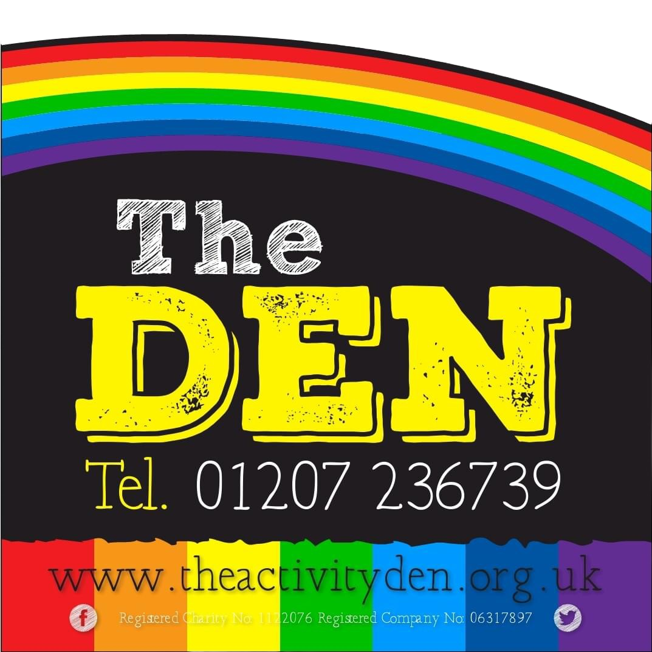

**The Den Local Market**

Terms & Conditions

1

***Trading at our Market:***

For all traders at The Den Local Market, there will be a set non-refundable fee, which may be subject to change following reviews. The fee will be as set out in the Terms and Conditions document that will be produced monthly for our Markets.

The Fees for a 6ft Space at our Market will be £15, this is per market stall required. Additional space if required can be purchased at a discounted rate.

For any traders requiring to hire 6ft tables for the market are available for hire at a cost of £5.

Power for your stall is also available upon request at no extra charge

(please state in an email to [keiranframe@theactivityden.org.uk](mailto:keiranframe@theactivityden.org.uk) what power requirements are needed prior to the event)

Any space that is booked by traders will be required to be paid in full via Bank Transfer prior to the event. Any unpaid stalls will not be reserved until payment is made in full. Confirmation of the reserved space will be confirmed via email. To book your space email [keiranframe@theactivityden.org.uk](mailto:keiranframe@theactivityden.org.uk) or for any further information.

***Prohibited Goods:***

Market Management will not permit the sale of any illegal, dangerous, or inappropriate products. The following, non-exhaustive, list of products, or product groups, is prohibited from sale at any of The Den Local Market or on any car boot sales that are licensed by Market Management.

* Guns, Replica Guns, Ornamental Swords and Knives (Except Kitchen Knives & Cutlery)
* Laser pens
* Vapes & Tobacco Products
* Live Animals
* Fireworks
* Counterfeit Goods
* Illegally Copied Videos, CD's, DVD's, MP3 disks & Computer Games
* Drugs, Drug Related Products or Items Promoting the Taking of Drugs (inc. Legal Highs)
* Inappropriate or Offensive Products as deemed by Market Management

Market Management reserves the right to amend the above list of products or product groups at any time.

***Trading Standards:***For Trading Standards conditions, please visit [www.durham.gov.uk/tradingstandards](https://www.durham.gov.uk/tradingstandards) for further guidance and rules that also apply at our Markets.